Test Case: tc003_SPX_Dev5_Crear_Requisicion_Spot_Tipo_Cobro_CC_Urgent
Step 1 - Enter username and password and click to button Enter : Credentials Entered
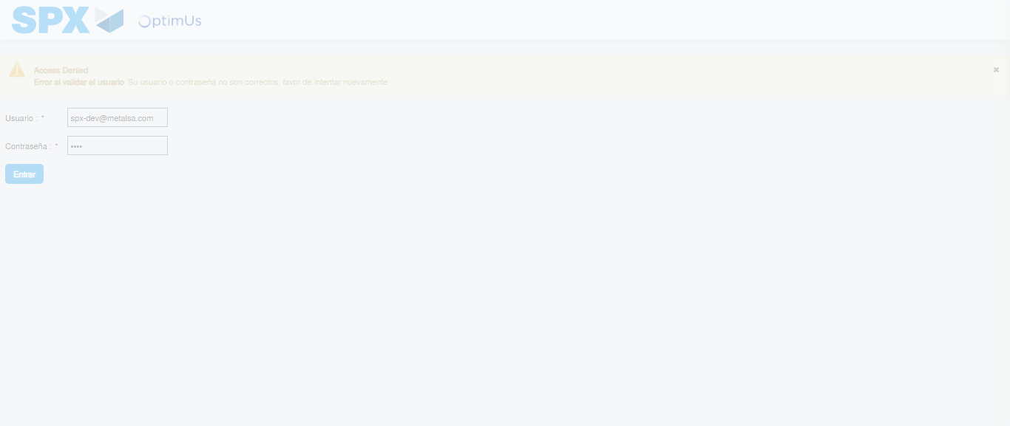Image file-name: QC_Testing-tc003_SPX_Dev5_Crear_Requisicion_Spot_Tipo_Cobro_CC_Urgent-1782239955939

Step 2 - Select to UEN and Access to Spot Buy Requisitions : UEN Correctly selected and Correct access
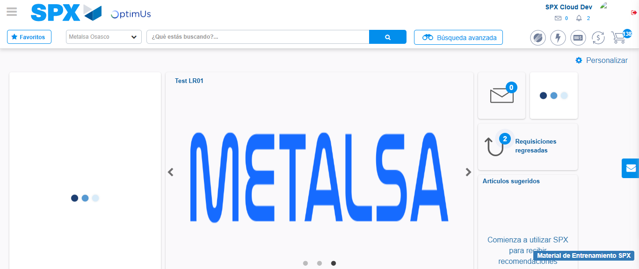Image file-name: QC_Testing-tc003_SPX_Dev5_Crear_Requisicion_Spot_Tipo_Cobro_CC_Urgent-1782239982169

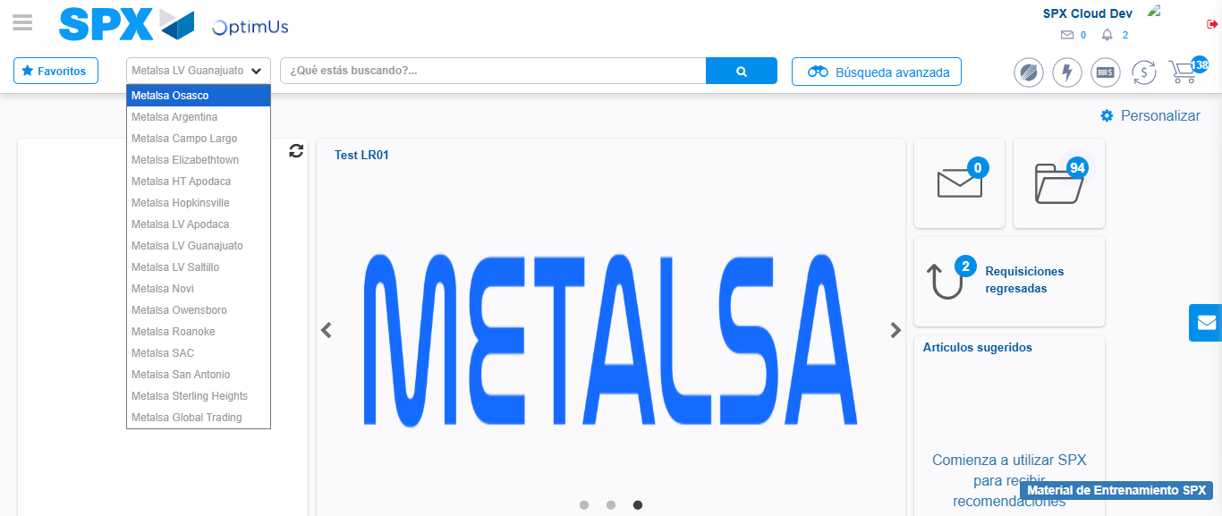Image file-name: QC_Testing-tc003_SPX_Dev5_Crear_Requisicion_Spot_Tipo_Cobro_CC_Urgent-1782239984765

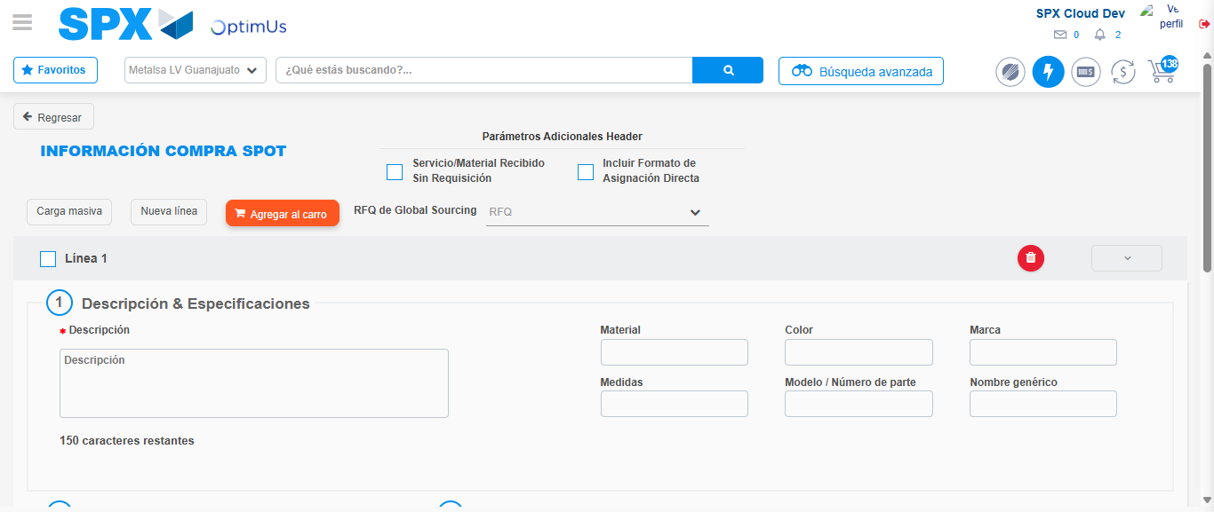Image file-name: QC_Testing-tc003_SPX_Dev5_Crear_Requisicion_Spot_Tipo_Cobro_CC_Urgent-1782240004753

Step 3 - Data Capture Spot Buy Requisition: Data captured correctly
Image file-name: QC_Testing-tc003_SPX_Dev5_Crear_Requisicion_Spot_Tipo_Cobro_CC_Urgent-1782240004961

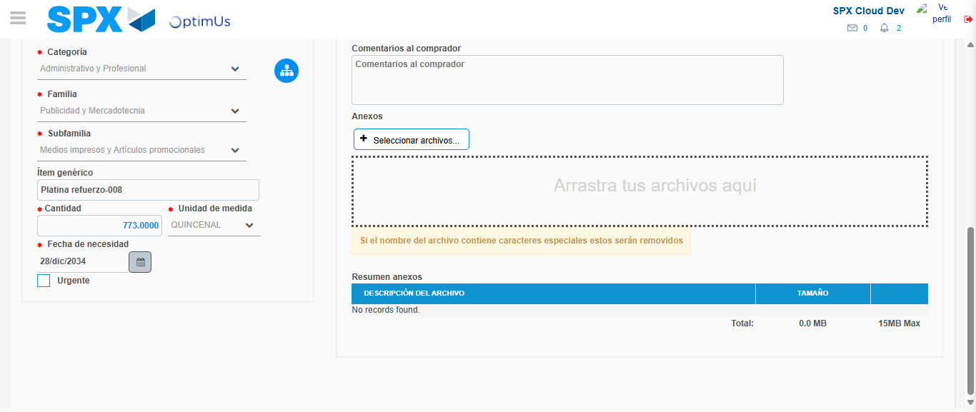Image file-name: QC_Testing-tc003_SPX_Dev5_Crear_Requisicion_Spot_Tipo_Cobro_CC_Urgent-1782240015951

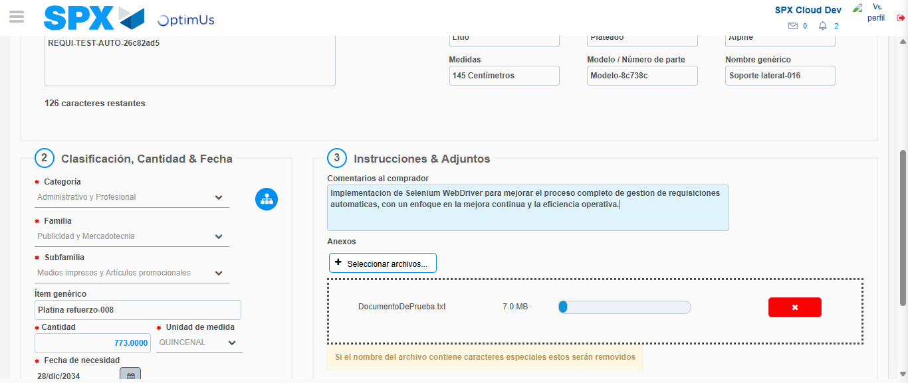Image file-name: QC_Testing-tc003_SPX_Dev5_Crear_Requisicion_Spot_Tipo_Cobro_CC_Urgent-1782240016771

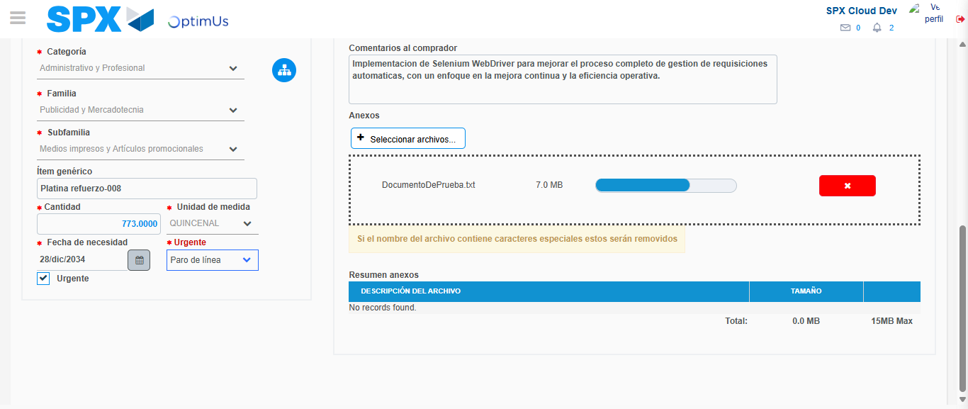Image file-name: QC_Testing-tc003_SPX_Dev5_Crear_Requisicion_Spot_Tipo_Cobro_CC_Urgent-1782240020936

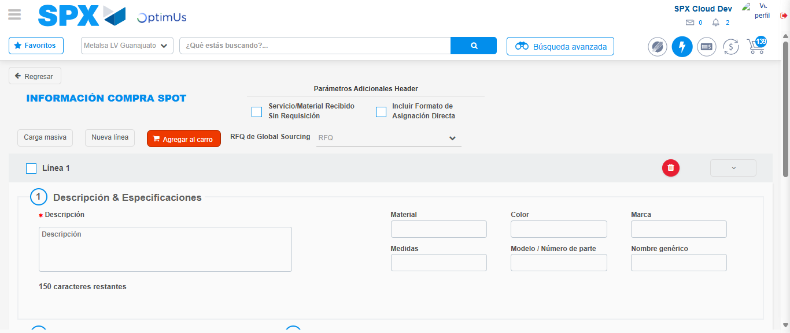Image file-name: QC_Testing-tc003_SPX_Dev5_Crear_Requisicion_Spot_Tipo_Cobro_CC_Urgent-1782240032971

Step 7 - Return to Main Page SPX : Return to Main Page SPX
Image file-name: QC_Testing-tc003_SPX_Dev5_Crear_Requisicion_Spot_Tipo_Cobro_CC_Urgent-1782239982169

Image file-name: QC_Testing-tc003_SPX_Dev5_Crear_Requisicion_Spot_Tipo_Cobro_CC_Urgent-1782239984765

Image file-name: QC_Testing-tc003_SPX_Dev5_Crear_Requisicion_Spot_Tipo_Cobro_CC_Urgent-1782240004753

Image file-name: QC_Testing-tc003_SPX_Dev5_Crear_Requisicion_Spot_Tipo_Cobro_CC_Urgent-1782240035190

Image file-name: QC_Testing-tc003_SPX_Dev5_Crear_Requisicion_Spot_Tipo_Cobro_CC_Urgent-1782240035316

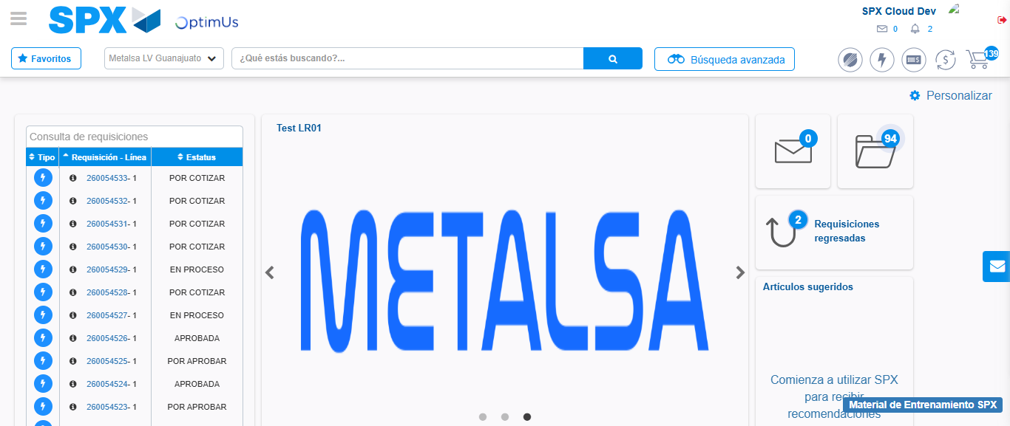Image file-name: QC_Testing-tc003_SPX_Dev5_Crear_Requisicion_Spot_Tipo_Cobro_CC_Urgent-1782240056446

Step 8 - Log Out : Log Out SPX
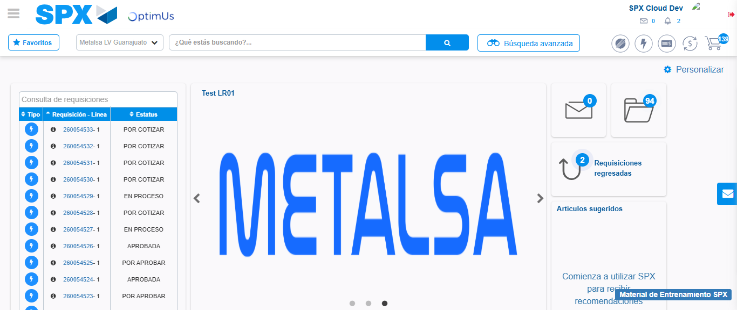Image file-name: QC_Testing-tc003_SPX_Dev5_Crear_Requisicion_Spot_Tipo_Cobro_CC_Urgent-1782240056675

